COINS-Xian-Pantikapaion-310-303 B.C.

[[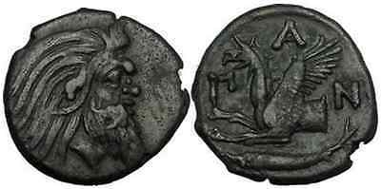](http://stores.ebay.com/Authentic-Ancient-Greek-Roman-Coins/_i.html?_nkw=Griffin&submit=Search)](http://stores.ebay.com/Authentic-Ancient-Greek-Roman-Coins/_i.html?_nkw=Griffin&submit=Search)

Greek city of  [Pantikapaion](http://stores.ebay.com/Authentic-Ancient-Greek-Roman-Coins/_i.html?_nkw=pantikapaion&submit=Search) in  [Cimmerian Bosporus](http://stores.ebay.com/Authentic-Ancient-Greek-Roman-Coins/_i.html?_nkw=Bosporus&submit=Search)  
Bronze 21mm (7.15 grams) Struck circa 310-303 B.C.  
Reference: HGC 7, 113  [Rare R1](http://stores.ebay.com/Authentic-Ancient-Greek-Roman-Coins/_i.html?_nkw=R1&submit=Search); MacDonald 69; Anohin 111; Sear 1700; B.M.C.3.20  
Wreath head of [Pan](http://stores.ebay.com/Authentic-Ancient-Greek-Roman-Coins/_i.html?_nkw=Pan&submit=Search), the satyr right.  
ΠΑΝ, Forepart of [griffin](http://stores.ebay.com/Authentic-Ancient-Greek-Roman-Coins/_i.html?_nkw=Griffin&submit=Search) advancing left; sturgeon below.